**DESIGN DOCUMENT**

**Group 6**

BY NOOR AHAMED SADIQUE 215605306,

TARIQ QURESHEY 216789166,

KAMAL PATEL 216280224

**Overview**

The Venn Diagram program first displays a welcome screen which provides the user with options. If the user wishes to create a Venn Diagram, the user can click on the create option and create their venn diagram. The user can also choose to exit or import a previously saved file from the app.

**Class Diagram**

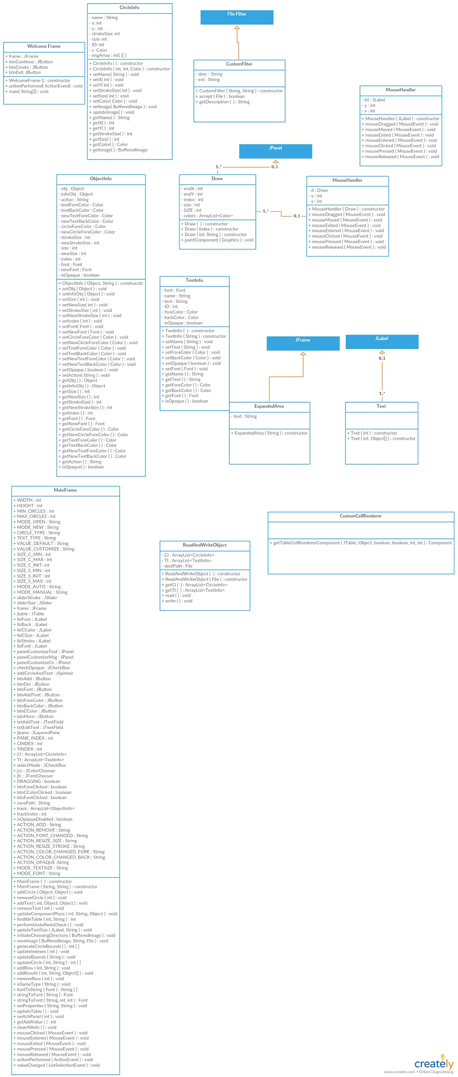

The Diagram above shows the class diagram for our application. When the application is first opened, the WelcomeFrame class is running which provides the user for the user on what they would like to do with the application. They would have the option to exit the program, import a file or create a venn diagram. After the user has picked an option which isn’t the exit option, the frame then moves onto the Main Frame which displays a window providing the user with multiple options on the right side, and the Venn diagram circles and text on the left side. Each time an option or a circle, or text is being added, the classes would reference from the Main class to whatever class is needed to reference depending on what option the user has clicked.

**Sequence Diagram Runtime Scenarios**

**Deleting circles from an existing Venn Diagram file:**

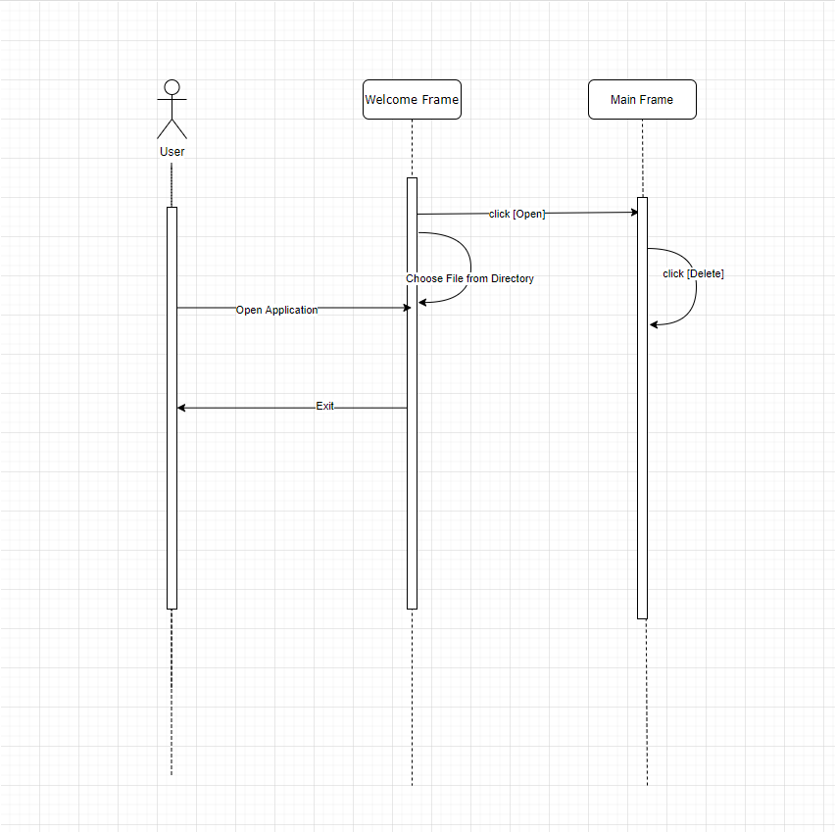

This sequence diagram shows the opening of an existing venn Diagram and deleting circles from it. It includes the quick selection and deletion of circles in the Venn Diagram application. The user starts off by running the program. The user has the option to exit if no changes are needed. The user then clicks Open and navigates through their directory to find their desired file that they want to open onto the main frame for modifications. They then click on the file and press open. The user can then select what circle they want to delete and click the Delete button.

**Creating a new Venn Diagram with and adding circles:**

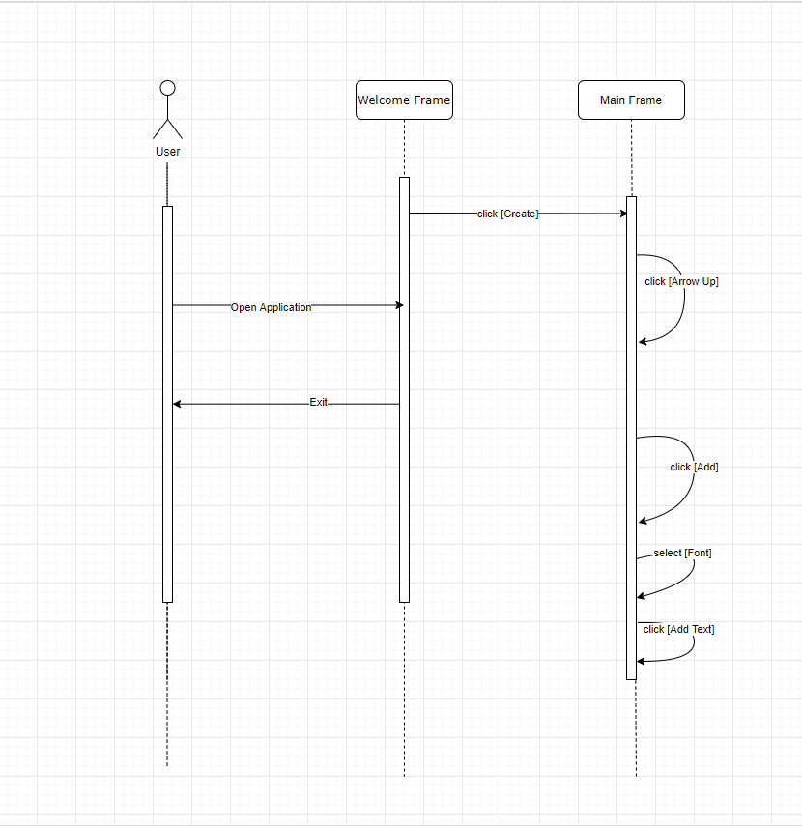

This sequence diagram shows the creation of a new Venn Diagram and adding circles to it. It includes the increasing number of circle adders as well as adding the actual circle and adding the text in the Venn Diagram application. The user starts off by running the program. The user has the option to exit if no changes are needed. The user then clicks on the Create button that prompts the main frame to appear where they can add circles. The user can click the arrow up button to increase the amount of circles added. Then the user will click add to add the number that was selected. Now the user can add text and once they click into the text box they can select multiple options but in this diagram the user selects Font and changes it. The user then inputs their desired text and clicks Add text to add the input to the main frame.

**Exiting the application:**

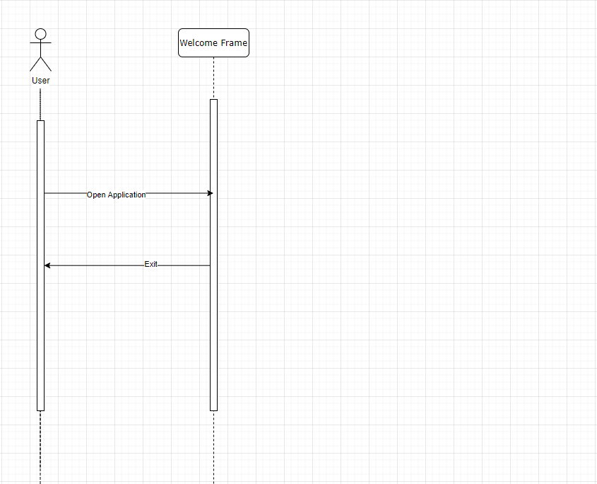

This sequence diagram shows the exiting of the Venn Diagram application. It includes the welcome frame only because no button is clicked to prompt the main frame. The user starts off by running the program. The user has the option to exit if no changes are needed. In this diagram the user does not need to make any changes so he clicks the Exit button and the application closes

**Maintenance Scenario**

Even though our program was working perfectly, there were some scenarios where the program does not do what the user wants it to do. Below are a few maintenance scenarios

1. Adding huge data or numerous data

The user may want to create a big comparison by adding huge numerous amounts of data. Since the size of the window is limited and fixed, the diagram can only take a limited amount of data to make it look clean and neat otherwise the data would look cramped and hard to read. To solve this, the developer can just add a storage button in each of the venn diagram circles where they can store their data in their specified circle. When they click on this button, it would bring up a huge list of the data stored in that circle. This button can be extremely useful for numerous amounts of data comparison.

2. Comparing different types of data in the Venn Diagram (Images, document etc.)

The user may want to sometimes compare different types of data which can be images, documents or whatever the user wants to compare in the Venn Diagram. To do this, the developer would have to first add an import function in the Main frame of the program. The developer would then add more options which would make the user pick on what type of file they would want to compare. The developer would then write different comparing algorithms depending on the type of file or data being compared in the Main. Depending on what the user wanted to compare, it would provide a different result for each. The developer would then provide the result in a percentage which shows the similarity between the two files.